BATCH-ID:LTVIP2025TMID61019

ORDERONTHEGO:YOURON-DEMAND FOODORDERINGSOLUTION

1. Introduction

**ProjectTitle**:OrderOnTheGo-YourOn-DemandFoodOrdering Solution

# Team:

# UDAYA RAJU

# HARISH

# ANIL KUMAR

# MANIKANTA

1. ProjectOverview

# Purpose:

OrderOnTheGo is a full-stack MERN application that simplifies food ordering. It allows users to browse a rich menu, filter based on food categories,additemstothecart,andcheckoutwithcash orUPI.Admins can manage orders, users, and menu items.

# KeyFeatures:

* + Userregistration/login
  + Productlistingwithfilters
  + Addtocartandplaceorder
  + Paymentoptions:CashonDelivery&UPI
  + Userprofilewithordertracking
  + Admindashboardtomanageusers,products,andorders

1. Architecture

# Frontend:

* + React.js(FunctionalComponents)
  + ReactRouterforrouting
  + ContextAPIforcartmanagement
  + CSSforstyling

# Backend:

* + Node.jswithExpress.js
  + RESTfulAPIs
  + Authenticationlogic(simplesession-based)

# Database:

* + MongoDB
  + MongooseforODM
  + Collections:Users,Products,Orders,Admin

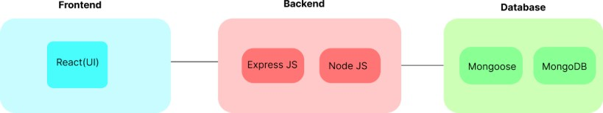

1. SetupInstructions

# Prerequisites:

* + Node.jsv18+
  + MongoDB(Atlasorlocal)
  + Git

# Installation:

1. Clone the repository: https://github.com/udayraju724/order-on-the-go
2. Navigatetobackendandinstalldependencies:

cd server npminstall

1. Navigatetofrontendandinstalldependencies: cd ../client

npminstall

1. Set up MongoDB connection string in server/.env MONGODB_URI=[https://food-0us6.onrender.com](https://food-0us6.onrender.com/)
2. FolderStructure

# Client(React):

client/ src/

pages/ #Containscart,login,register,productlist,etc. components/ # Header, Navbar

context/ # Cart context assets/images#Foodimagesandlogo

**Server(Node+Express)**: server/

index.js # Server entry point models/ #Mongooseschemas routes/ # API route handlers

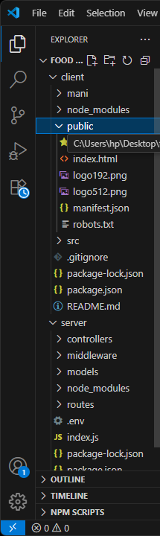

1. RunningtheApplication

# Frontend:

cd client npmstart

# Backend:

cdserver

nodeindex.jsornodeapp.js

1. APIDocumentation
   * **GET**/api/products:Fetchallfood items
   * **POST**/api/register:Registeruser
   * **POST**/api/login:Login user
   * **POST**/api/cart:Addto cart
   * **POST**/api/orders:Placeorder
   * **GET**/api/orders/:userId:Getuserorders
2. Authentication
   * SimpleloginlogicwithlocalStoragetokensimulation
   * Onlyauthenticateduserscanaccesscartandprofile
   * Adminroutesrestricted
3. UserInterface
   * Responsivedesign
   * Categoryfilters(Starters,MainCourse,etc.)
   * Cartsummarywith price
   * Profilepageshowingorderhistoryanduserinfo
4. Testing
   * Manualtestingofallroutes
   * UItestingon Chrome
5. ScreenshotsorDemo
   * **LandingPage**:Displaysfullmenu
   * **CartPage**:Showsaddeditemsandtotal
   * **Login/Register**:Foruseraccounts
   * **AdminDashboard**:Viewallorders,users

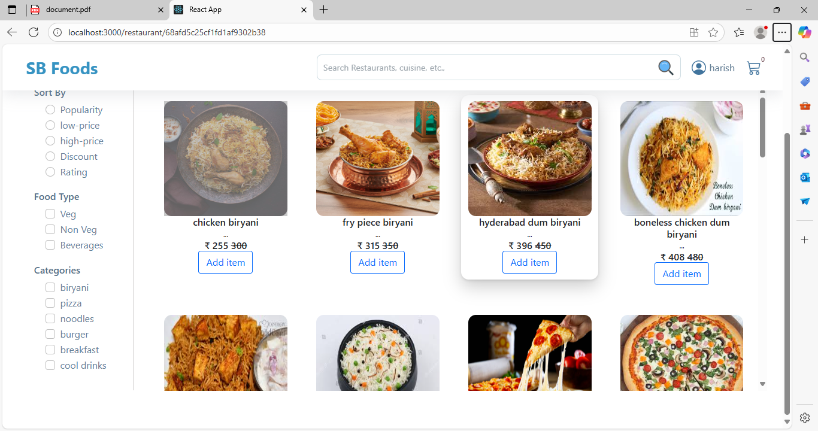

* + ​

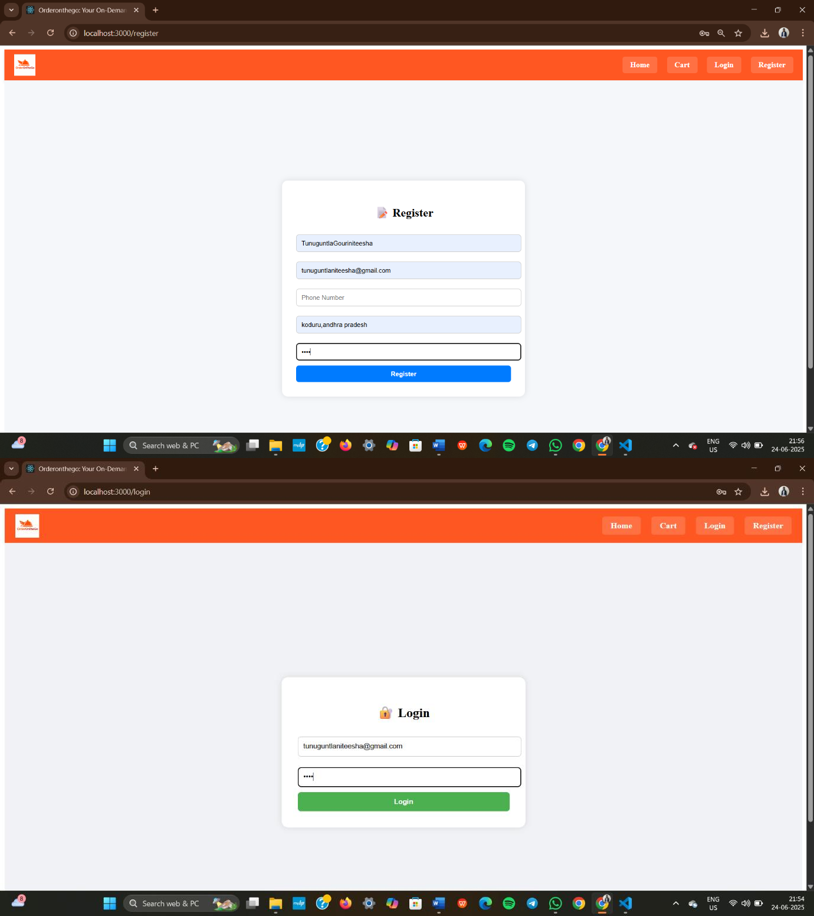

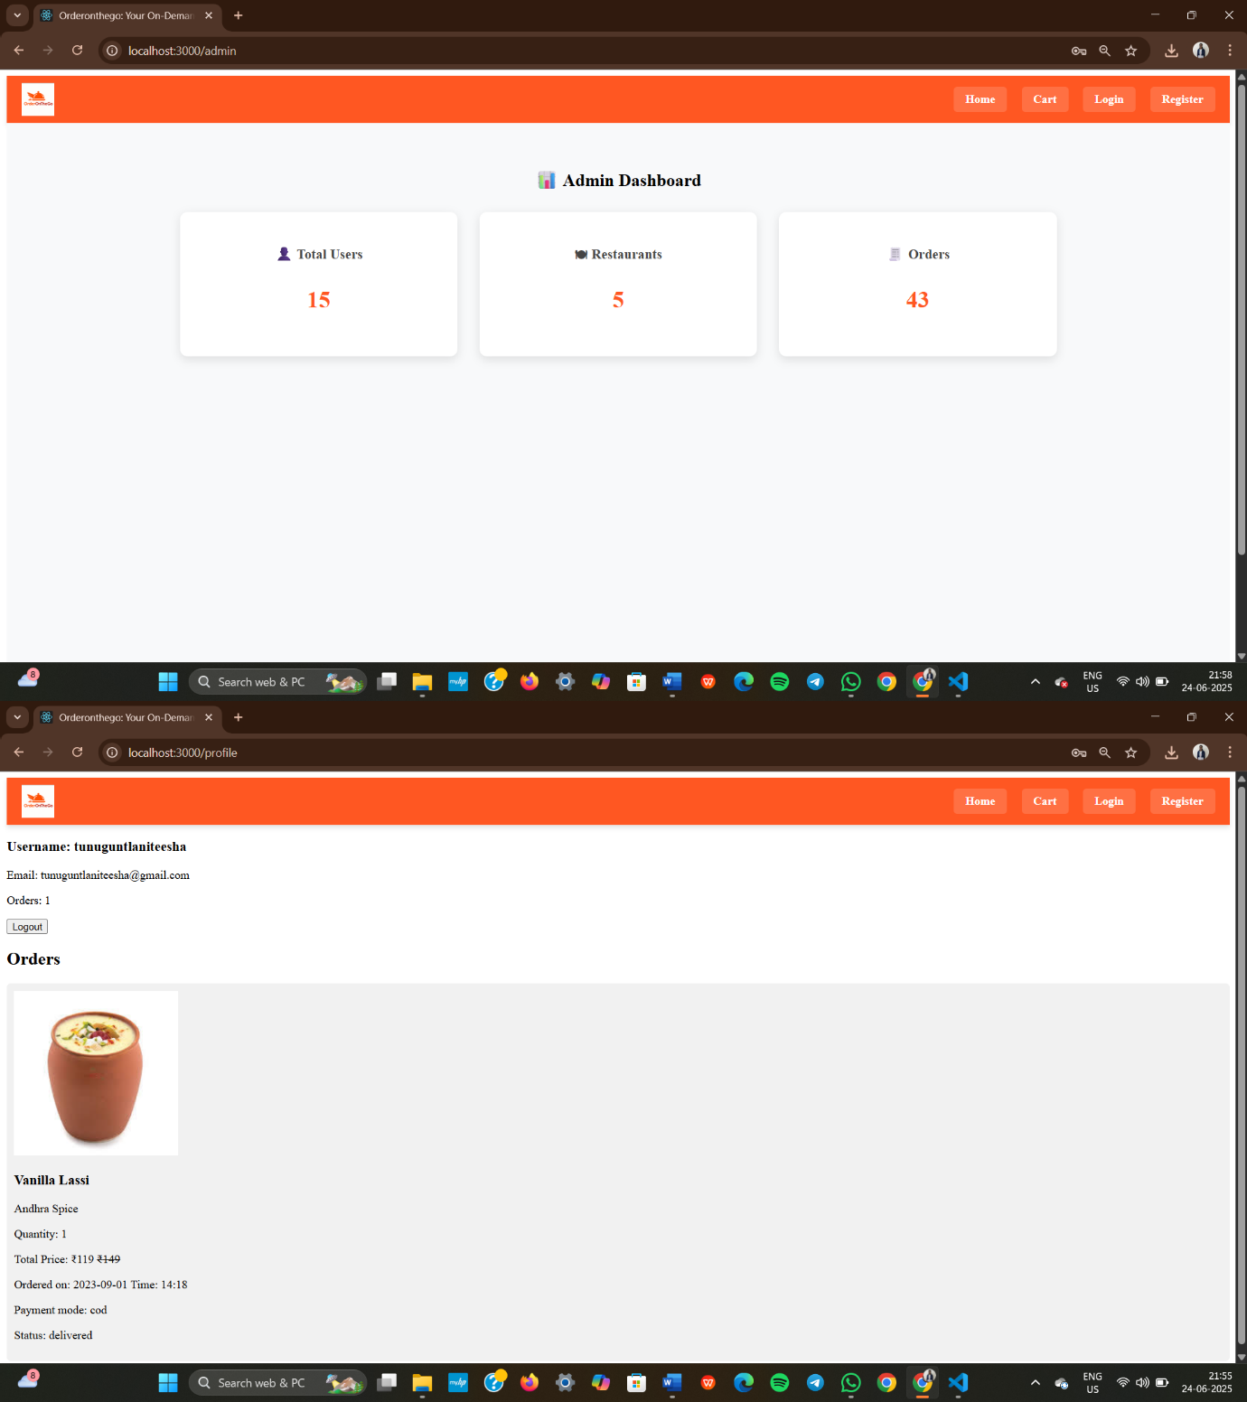

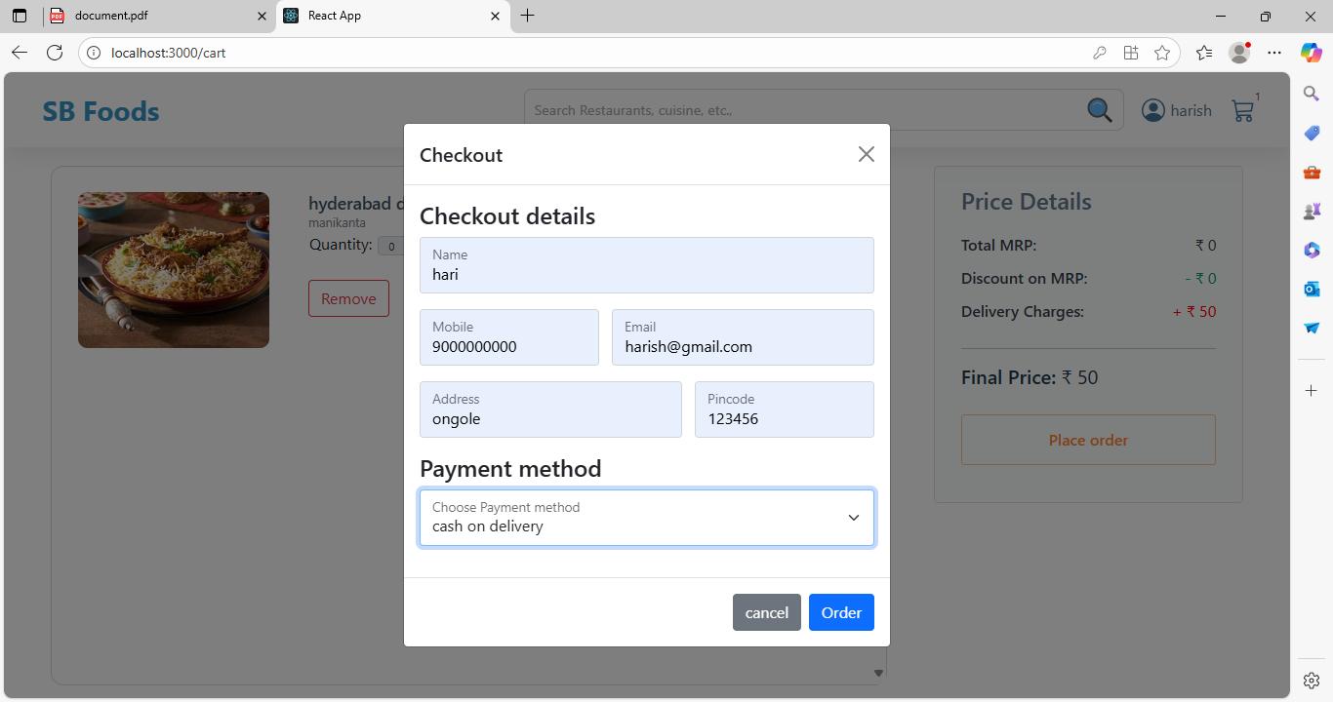

1. KnownIssues
   * Nopersistentlogin(usesfrontendlogiconly)
   * Noimageuploadfornewitems
2. FutureEnhancements
   * JWT-basedauthentication
   * Restaurantonboardingmodule
   * Dynamicimageuploads
   * Deliverypartnerintegration
   * PWAsupportformobileordering

**HappyOrderingwithOrderOnTheGo!**